|  |  |  |
| --- | --- | --- |
| |  | | --- | | **Design Standard** | |  | |
| **FOR EDUCATIONAL USE ONLY** |

|  |
| --- |
|  |
|  |
|  |
|  |
|  |
|  |
| [www.minipcb.com](http://www.minipcb.com)  This document is available for free as a download from the GitHub repository: <https://github.com/miniPCB>  This document is associated with the miniPCB Channel on YouTube:  <https://www.youtube.com/@minipcb> |

TABLE OF CONTENTS

1. Introduction 6

2. Board Design 6

3. Part Identification Number 9

4. Board Fabrication 18

5. Change and Liability Notice 19

6. Trademark Notice 19

7. Revision History 20

TABLE OF FIGURES

Figure 1 – Part Identification Number 9

Figure 2 – Exemplar Revision History Table 15

**TABLE OF TABLES**

Table 1 – Exemplar Revision History Table 15

Table 2 – GitHub Repository 15

Table 3 – Exemplar Pinmap Table 16

Table 4 – Exemplar Pinout Table 16

Table 5 – Exemplar Parts List 17

Table 6 – PCB Manufacturing Options 18

Table 7 – Stencil Manufacturing Options 18

# Introduction

This document outlines specifications for compact, modular electronic assemblies that facilitate the use of interchangeable circuit board assemblies, making them particularly well-suited for educational purposes.

# Board Design

## Introduction

Most boards include a logo, mounting holes, layout region and main connector.

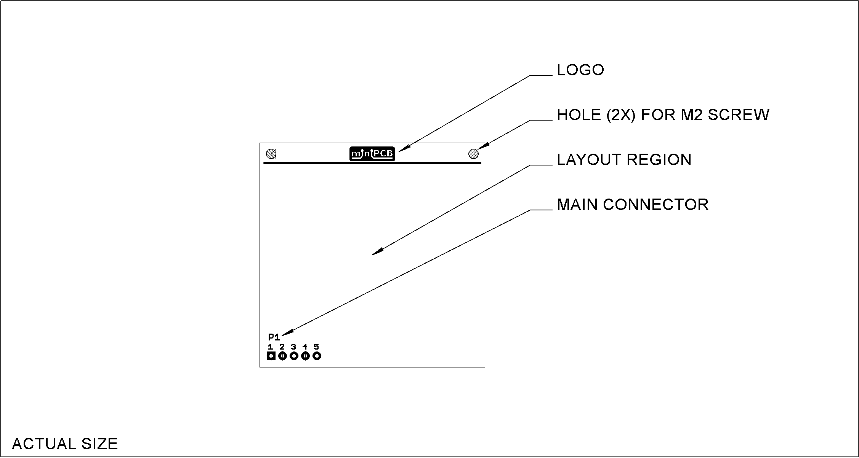

## Main Connector

### Reference Designator

* The reference designator for the main connector is always J1 or P1.
* The prefix J is used to reference the less movable connector. This is typically the socket, or receptacle, side on the interface device assembly.
* The prefix P is used to reference the more movable connector. This is typically the pin, or plug, side on the circuit board assembly.

### Parts

* Right-angle orientation is standard; any orientation may be used.
* The part numbers listed here are unique to the miniPCB venture.

### Pinmaps

The first three pins are dedicated to power and ground. Subsequent pins are consistent with VIVA header pinouts. A pinout table similar to this may be used in datasheet documentation.

|  |  |  |  |
| --- | --- | --- | --- |
| PIN | PIN NAME | FUNCTION | NOTES |
| 1 | GND | Ground |  |
| 2 | +V | Supply, DC, Positive | No greater than +60 VDC |
| 3 | -V | Supply, DC, Negative | No greater than -60 VDC |
| 4 |  |  |  |
| 5 |  |  |  |
| 6 |  |  |  |
| 7 |  |  |  |

The remainder of this page intentionally blank.

## Board Layout

### Reference Designators

Reference designators will be formatted similar to these settings:

|  |  |
| --- | --- |
| PROPERTY | SETTING |
| Font | Vector |
| Font Size | 1.5 mm |
| Font Width | 12% |
| Layer | tNames or bNames |

### Layout Specifications

|  |  |  |
| --- | --- | --- |
| PROPERTY | SMD | THD |
| Component Placement | Top Side | Top Side |
| Grid for Component Placement | 0.5 mm | 0.5 mm |
| Uncut Ground Plane | Bottom | Top |
| Trace Side | Top Side | Bottom Side |
| Trace Width | 0.3 mm | 0.5 mm |
| Via Drill Diameter | 0.5 mm | 0.5 mm |
| Edge Keepout | 1.5 mm | 1.5 mm |

### Test Points

Test points will be included when they are needed to test or adjust the circuit.

### Part Number

A part number will be placed on the bottom side of the board, in the region furthest away from the main connector. The part number will be placed in both copper and silkscreen.

# Part Identification Number

## Introduction

This section specifies the Part Identification Number (PIN). The PIN provides information concerning the part’s circuit, component sizes, and miniPCB revision.

The PIN is in the following form:

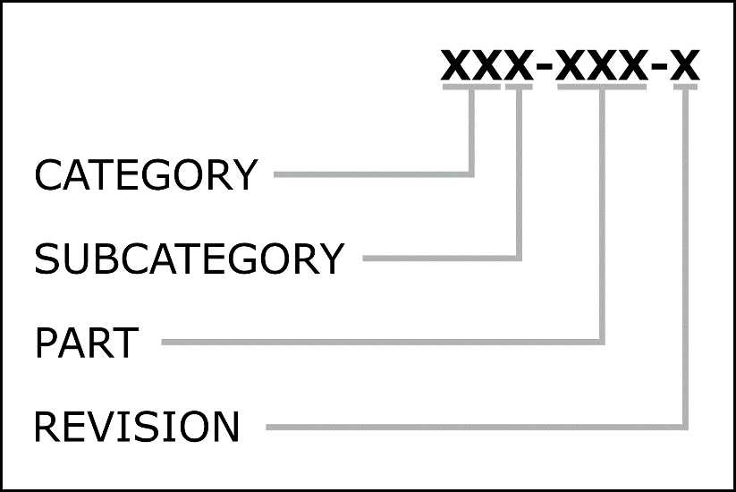

Figure – Part Identification Number

|  |  |  |  |
| --- | --- | --- | --- |
| CATEGORY | SUBCATEGORY | PART | REVISION |
| per Section 3.2.1 | per Section 3.2.2 | per Section 3.2.2.15 | per Section 3.2.4 |

The remainder of this page intentionally blank.

## PIN Classifications

### Category

Categories are identified by two (2) digits.

|  |  |  |
| --- | --- | --- |
| CLASSIFICATION ID | TITLE | DESCRIPTION |
| 00X-XXX | Test Boards | PCBs that enable electronic test setups |
| 01X-XXX | Components | PCBs that enable component test setups |
| 02X-XXX | Sensors | PCBs with layouts of sensing circuits |
| 03X-XXX | Actuators | PCBs with layouts of actuator circuits |
| 04X-XXX | Amplifiers | PCBs with layouts of amplifier circuits |
| 05X-XXX | Filters | PCBs with layouts of filter circuits |
| 06X-XXX | Oscillators | PCBs with layouts of oscillators |
| 07X-XXX | Radio | PCBs with layouts of radio frequency circuits |
| 08X-XXX | Signal Converters | PCBs with layouts of signal converter circuits |
| 09X-XXX | Power | PCBs with layouts of power circuits |
| 10X-XXX | Digital | PCBs with layouts of digital circuits |
| 11X-XXX | Computing | PCBs with layouts of computer circuits |
| 12X-XXX | Communication | PCBs with layouts of communication circuits |
| 13X-XXX | Games | PCBs with layouts for game circuits |
| 14X-XXX | Home Automation |  |
| 15X-XXX | Wearables |  |

### Subcategory

Subcategories are identified by a single letter. Each subcategory can hold up to two hundred (200) unique circuits. Categories and subcategories will be added as more circuits are desired.

#### Test Boards, 00

* 00A, Probe and prototyping
* 00B; Test device and setup boards
* 00C; Signal Data

#### Components, 01

* 01A; Discrete Components
* 01B; Integrated Components
* 01C; Modular Components

#### Sensors, 02

* 02A; Human interface
* 02B; Environment interface
* 02C; Machine interface

#### Actuators, 03

* 03A; Mechanical
* 03B; Thermal
* 03C; Photic

#### Amplifiers, 04

* 04A; Operational amplifiers
* 04B; Transistor amplifiers
* 04C; Application specific amplifiers

#### Filters, 05

* 05A; Passive
* 05B; Active

#### Oscillators, 06

* 06A; Harmonic (Linear)
* 06B; Relaxation (Nonlinear)

#### Radio, 07

* 07A; Transmitters
* 07B; Receivers
* 07C; Transceivers

#### Signal Converters, 08

* 08A; Analog to Digital
* 08B; Digital to Analog
* 08C; Voltage to Current
* 08D; Current to Voltage
* 08E; Voltage to Frequency
* 08F; Frequency to Voltage
* 08G; Time to Voltage

#### Power, 09

* 09A; Voltage limiters, references, regulators
* 09B; Current limiters, mirrors, regulators
* 09C; Power converters, isolators
* 09D; Fuses, rectifiers, filters, transformers
* 09E; RESERVED
* 09F; Optoisolators

#### Digital, 10

* 10A; Logic Gates
* 10B; Logic Devices (clocks, registers, flip-flops, etc.)
* 10C; Digital Systems

#### Computing, 11

* 11A; Educational
* 11B; Developmental
* 11C; Industrial

#### Communication, 12

* 12A; Wired
* 12B; Wireless

#### GAMES, 13

* 13A; Luck Games (i.e. chance)
* 13B; Computation Games (i.e. strategy)
* 13C; Empathy Games (i.e. bluffing)

#### HOME AUTOMATION, 14

* 14A; Power
* 14B; Sensors
* 14C; Actuators

#### WEARABLES, 15

* 15A; Microphones
* 15B; Bio sensors

### Part

Each circuit is allotted five (5) sequential part numbers, 0-4 or 5-9.

|  |  |  |
| --- | --- | --- |
| PART NUMBER | LAYOUT | DESCRIPTION |
| XXX-XX0 | THD | Layout uses through hole device components. |
| XXX-XX1 | SMD, 1206 | Layout uses 1206 surface mount device components |
| XXX-XX2 | SMD, 0805 | Layout uses 0805 surface mount device components |
| XXX-XX3 | SMD, 0402 | Layout uses 0402 surface mount device components |
| XXX-XX4 | RESERVED | Reserved for future use. |
|  | | |
| XXX-XX5 | THD | Layout uses through hole device components. |
| XXX-XX6 | SMD, 1206 | Layout uses 1206 surface mount device components |
| XXX-XX7 | SMD, 0805 | Layout uses 0805 surface mount device components |
| XXX-XX8 | SMD, 0402 | Layout uses 0402 surface mount device components |
| XXX-XX9 | RESERVED | Reserved for future use. |

### Revision Identification

Final release revision identification increments A1, A2, A3, etc. for minor revisions, and A1, B1, C1, etc. for major revisions. Prototype revisions increment similar to: A1-01, A1-02, A1-03, etc.

### Revision History Tables

A revision history table will be included on schematic engineering drawings.

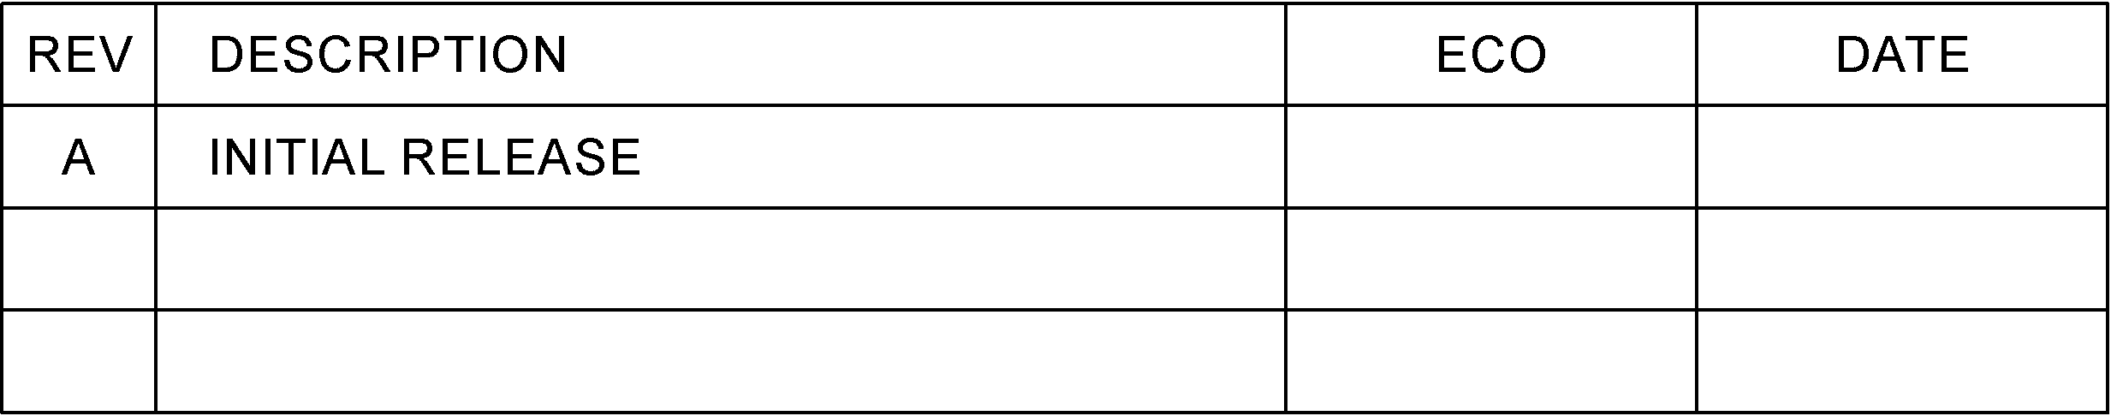

Figure – Exemplar Revision History Table

A revision history table will be included in documents.

Table – Exemplar Revision History Table

|  |  |  |  |
| --- | --- | --- | --- |
| REV | DESCRIPTION | ECO | DATE |
| A | Initial Release | ### | DDMMMYYYY |

### Review and Approval

Engineering documentation will be reviewed, approved, and signed by a qualified engineer prior to release.

### Engineering Change Orders

ECObase will be used to record engineering change orders.

### File Repository

Engineering files and records will be saved in a GitHub repository owned by Nolan Manteufel.

### Public Disemination

Engineering files and records will be published to a public GitHub repository owned by Nolan Manteufel.

Table – GitHub Repository

|  |  |
| --- | --- |
| REPOSITORY | LOCATION |
| GitHub | https://github.com/miniPCB |

## Datasheets

### Board Views

Include board views of the top and bottom sides. If test points are present, include dimensions to each test point.

### Connector Pinmaps

For each connector, include a pinmap table similar to this:

Table – Exemplar Pinmap Table

|  |  |  |  |
| --- | --- | --- | --- |
| PIN | PIN NAME | FUNCTION | NOTE |
| 1 | GND | Ground | Reference for signal measurements. |
| 2 | +V | DC Supply, Positive | Limited by component ratings. |
| 3 | -V | DC Supply, Negative | Limited by component ratings. |
| 4 |  |  |  |
| 5 |  |  |  |

### Component Pinouts

For components with pinouts that need to be known during component selection, include a pinout table similar to this:

Table – Exemplar Pinout Table

|  |  |  |
| --- | --- | --- |
| PIN | PIN NAME | FOOTPRINT (TOP VIEW) |
| 1 |  |  |
| 2 |  |
| 3 |  |
| 4 |  |
| 5 |  |
| 6 |  |
| 7 |  |
| 8 |  |

### Parts List

Include a parts list table similar to this:

Table – Exemplar Parts List

|  |  |  |  |  |  |
| --- | --- | --- | --- | --- | --- |
| FIND | REF. DES. | COMPONENT | FOOTPRINT | PART VALUE | COMMENTS |
| 1 | R1 | Resistor | 0805 |  |  |
| 2 | R2 | Resistor | 0805 |  |  |
| 3 | R3 | Resistor | 0805 |  |  |
| 4 | C1 | Capacitor | 0805 |  |  |
| 5 | C2 | Capacitor | 0805 |  |  |
| 6 | C3 | Capacitor | 0805 |  |  |
| 7 | Q1 | Transistor | SOT-23 |  | Pinout (123: BEC|GSD) |
| 8 | P1 | Header Pins | 5-pin |  |  |

The remainder of this page intentionally blank.

# Board Fabrication

## Introduction

This section specifies manufacturing options and panels.

## Manufacturing Options

Table – PCB Manufacturing Options

|  |  |
| --- | --- |
| PCB PROPERTY | SETTING |
| Board Material | FR4 / Tg130 |
| Number of Layers | 2 |
| Board Thickness | 1.6 mm |
| PCB Color | Green |
| Surface Finish | HASL |
| Copper Weight | 1 oz. |
| Minimum Hole Size | 0.3 mm |
| Trace Width Spacing | 6/6 mil |

Table – Stencil Manufacturing Options

|  |  |
| --- | --- |
| STENCIL PROPERTY | SETTING |
| Thickness | 0.12 mm |
| Polishing Technique | Polished |

## Panels

miniPCBs will be panelized so that they are within 100 x 100 mm overall dimensions and can be v-scored.

# Change and Liability Notice

This document is subject to change without notice. While effort has been made to ensure the accuracy of the material contained within this document, Nolan Manteufel shall under no circumstances be liable for incidental or consequential damages or related expenses resulting from the use of this document.

# Trademark Notice

miniPCB is a trademark of Nolan Manteufel.

This specification does not constitute permission to use the miniPCB trademark.

|  |  |  |
| --- | --- | --- |
| WORDMARK | FIGUREMARK | FIGUREMARK |
| miniPCB™ | A picture containing drawing  Description automatically generated™ | Icon  Description automatically generated™ |

# Revision History

|  |  |  |  |
| --- | --- | --- | --- |
| REV | DESCRIPTION | ECO | DATE |
| A | Initial Release | N/A | 19AUG2022 |
| B | Added images for BIN, PIN, and IDB panels. | N/A | 20AUG2022 |
| C | Added URL to the newly created miniPCB GitHub.  Added ENGINEERING DOCUMENTATION section.  Added circuit category 12; COMMUNICATION. | N/A | 10NOV2022 |
| D | Added miniPCB board designs (e.g. PCB50 and PCB100).  Modify pin pitch on P1 connector from 2.54 to 2.5 mm.  Added URL to miniPCB Channel on YouTube.  Added COMPONENT FOOTPRINTS section.  Added circuit category 13; GAMES.  Modified circuit category 11; COMPUTING.  Added circuit category 14; HOME AUTOMATION.  Added circuit category 15; WEARABLES. | N/A | 04OCT2023 |
| E | Rewrote introduction.  Removed Mechanical and Schematic sections. | N/A | 26OCT2023 |